**Front End Development Project**

**( The project is based on HTML, CSS, and Javascript. )**

**Final Report**

**Topic:- NIROG : Meditate At Home**

**Submitted To :-**

**Faculty Name :- Priya Virdi**

**Submitted By:-**

**Name:- Ashwani Kumar**

**Roll No :- A10**

**Registration Number :- 11806645**

**Subject :- INT219**

**Section :- KM090**

**Email ID :- ak5594137@gmail.com**

**Table Of Contents**

**Introduction To Technologies** 3

**Introduction To Project** 3

**Objectives** 3

**Theory** 4

**Modules** 4

**Log In Page**  6

**Forgot Password Page**  7

**Home Page**  8

**Meditate At Home Page**  9

**Twitter Feeds Page**  10

**Online Transaction Page**  11

# **Introduction To Technologies**

A web project is the process of developing and creating a Web site, activities in a network which are aimed at a pre-defined goal. The network can be both accessible for everyone, as in the [Internet](https://en.wikipedia.org/wiki/Internet). The goal of Web projects is the transfer of static and dynamic content - both directly to end users, as well as indirectly through means of various kinds of interfaces. Web projects are based on [TCP/IP](https://en.wikipedia.org/wiki/TCP/IP) (Transfer Control Protocol/Internet Protocol) technology and concern the transfer of static and dynamic content.

A Web project involves many aspects, including [programming](https://en.wikipedia.org/wiki/Programming_language)and the accompanying [software](https://en.wikipedia.org/wiki/Software) development, Web business, [Web server](https://en.wikipedia.org/wiki/Web_server) and network administration, [hosting](https://en.wikipedia.org/wiki/Hosting_service), graphics/design, the development and administration of [databases](https://en.wikipedia.org/wiki/Database), construction of [interfaces](https://en.wikipedia.org/wiki/Interface_(computing)), project management and quality assurance, [search engine optimization](https://en.wikipedia.org/wiki/Search_engine_optimization), the maintenance of data in content management/editing systems and much more.

Programming for a web project may be accomplished using a markup language (such as [HTML](https://en.wikipedia.org/wiki/HTML)), scripting languages ([JavaScript](https://en.wikipedia.org/wiki/JavaScript) ), for styling our website to look to appropriate ( such as CSS ) and for complex programming ( we can use languages like C++ and Java, etc).

When hosting a Web project, the primary objectives include the provision of the necessary hardware and software infrastructure, and an assurance that the highest possible levels of availability and reliability are offered. [Web design](https://en.wikipedia.org/wiki/Web_design) for Web projects must offer a high quality of use for persons interacting with the website.

# **Introduction To Project**

**(NIROG : Meditate At Home)**

NIROG is used to manage all the activity related to Yoga And Meditation. In this field, We provide all kind of solutions simultaneously to rejuvenate your life as it is very hard to bring smile to a person’s face. To make an life happier and successful, NIROG lend different service like Webinar, Meditate At Home and so on. It will be the best place to make your life healthy and prospering. Our platform will have all services and assistance as per your need and consideration of our users. It will stand to its objective which is easier to adapt and get in handy. At Last, I would state that my project will be completely genuine, handy and new thing to explore which can make you feel happy, and healthy with increase in concentration and presence of mind.

# **Objectives**

NIROG is going to be very appraisal and advancement in Present Edition of Yoga And Meditation. The Platform will very proper site of interest with proper validation. It can also be used for exploration. It is going to make you rejuvenate your life by increasing your concentration and stability of mind. It is going to make you learn different kinds of Yoga and it’s advantage. It is going to saving the time of the user and facilitate them as per their demand. User can register for any happening event from anywhere and can enquire about their requirement. Furthermore, I will stand to my objective which is the awareness of the power of Yoga and Meditation in our daily lives.

# **Theory**

Overall, I have tried show function of HTML, CSS, and JavaScript. I have tried to organize our text and data through HTML. We have tried to give style and texture to our website with help of CSS. We have tried to foreward the response and pop-up to the user with the help of JavaScript.

In HTML, Form with it various attributes, Marquee Tag, Hover, anchor tag, link tag, etc. HTML is used to create electronic documents (called pages) that are displayed on the [World Wide Web](https://www.computerhope.com/jargon/w/www.htm). Each Page contains a series of connections to other pages called [hyperlinks](https://www.computerhope.com/jargon/h/hyperlin.htm).

This language code ensures the proper formatting of text and images so that your [Internet browser](https://www.computerhope.com/jargon/b/browser.htm) may display them as they are intended to look. Without HTML, a browser would not know how to display text as [elements](https://www.computerhope.com/jargon/h/html-element.htm) or load images or other elements. HTML also provides a basic structure of the page, upon which [Cascading Style Sheets](https://www.computerhope.com/jargon/c/css.htm) are overlaid to change its appearance. One could think of HTML as the bones (structure) of a web page, and CSS as its skin (appearance).

In CSS, We have mainly External CSS to style our Webpages. We have this language for describing the presentation of Web pages, including colors, layout, and fonts. It allows one to adapt the presentation to different types of devices, such as large screens, small screens, or printers. The combination of HTML with CSS makes it easier to maintain sites, share style sheets across pages, and tailor pages to different environments.

In JavaScript, We have used various Dialog Boxes for Alert, Confirm, and Validation. We have used Client-side validation. We have used to Validate user input in an HTML form before sending the data to a server. We used to a Build forms that respond to user input without accessing a server. We have used as to Change the appearance of HTML documents and dynamically write HTML into separate Windows. We have used as to Display popup windows and dialog boxes (like alert dialog box, confirm dialog box and prompt dialog box).

In Addition, I have also tried to make module which can let you meditate at home with the help of HTML, CSS And JavaScript having able to switch the mode and with different time duration.

# **Modules**

With the help of HTML (Hypertext Mark-up Language), CSS (Cascading Style Sheet), And JavaScript, we have set different modules to make our project. We have made form for Log In Page, Forgot Password Page, Home Page With Extension to Twitter Feeds, Online Transaction Page and Meditate At Home Page all made with mixture of HTML, CSS And JavaScript having proper validation and layout. We have used different tags like Marquee Tags, Anchor Tags of HTML, External CSS, and Various Pop-up and Alert text through JavaScript having proper constraint.

## **Log In Page :-**

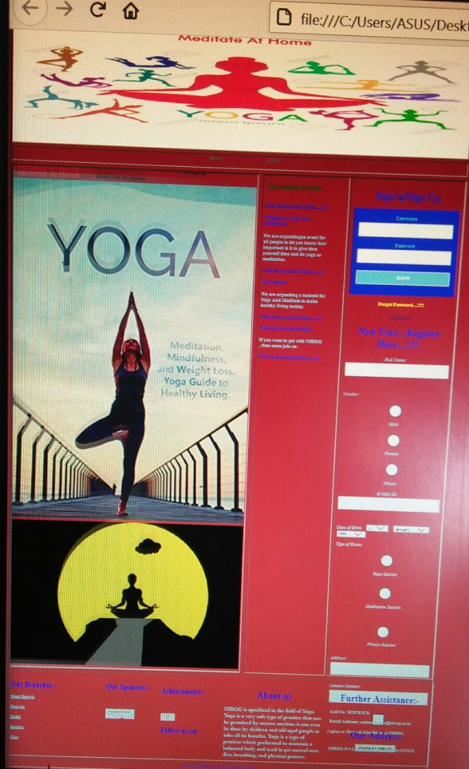

## **Forgot Password Page :-**

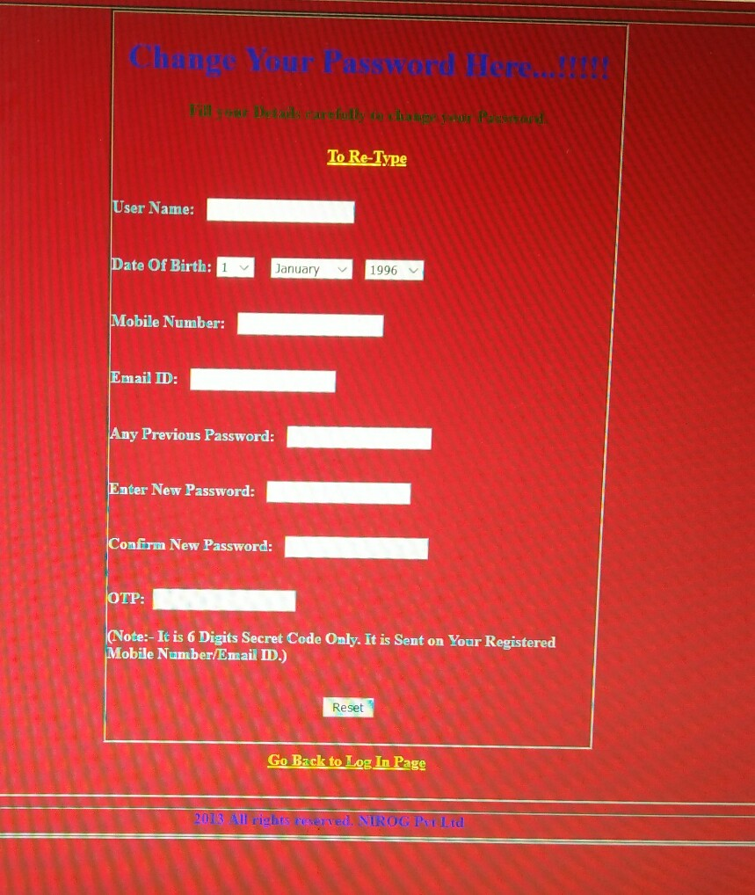

## **Home Page :-**

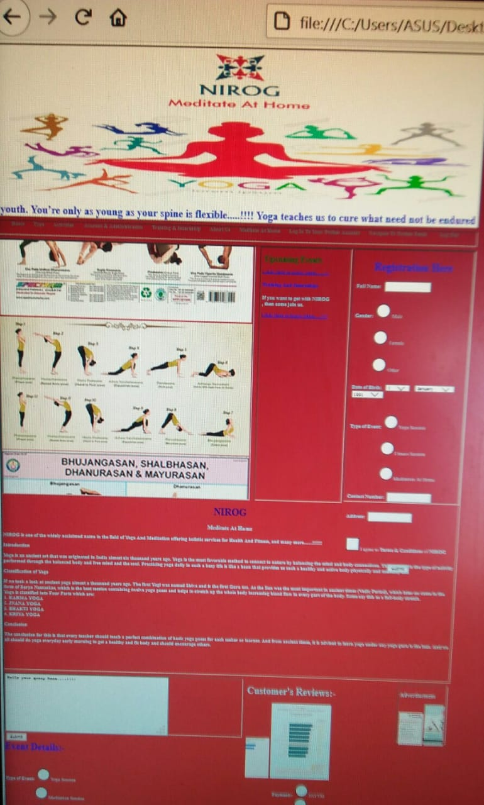

**Meditate At Home Page :-** 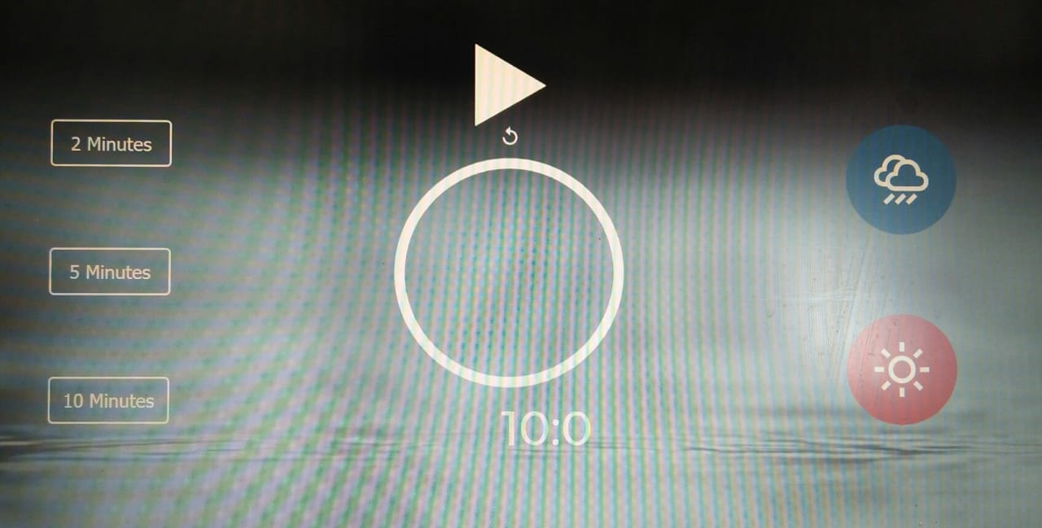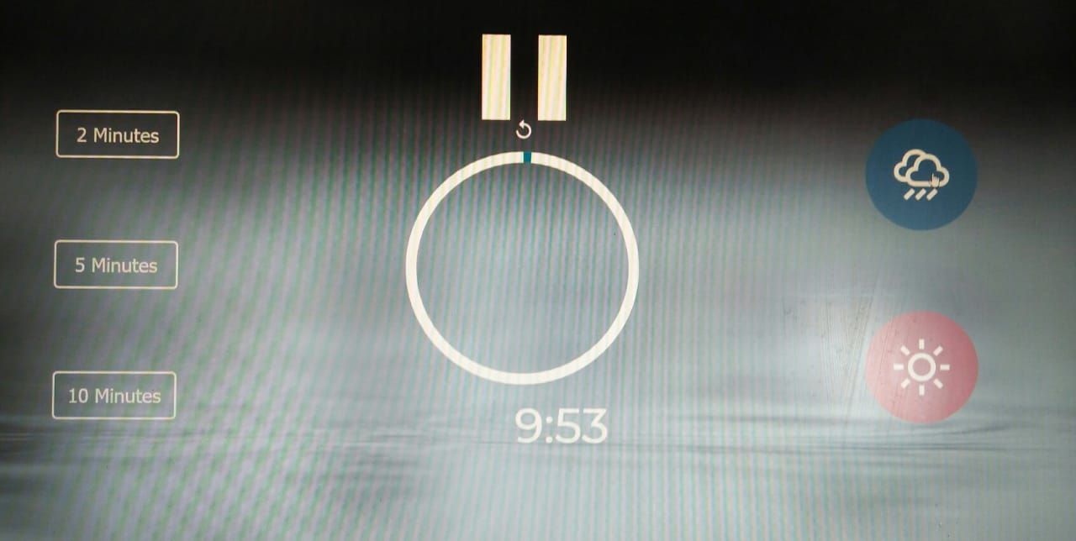

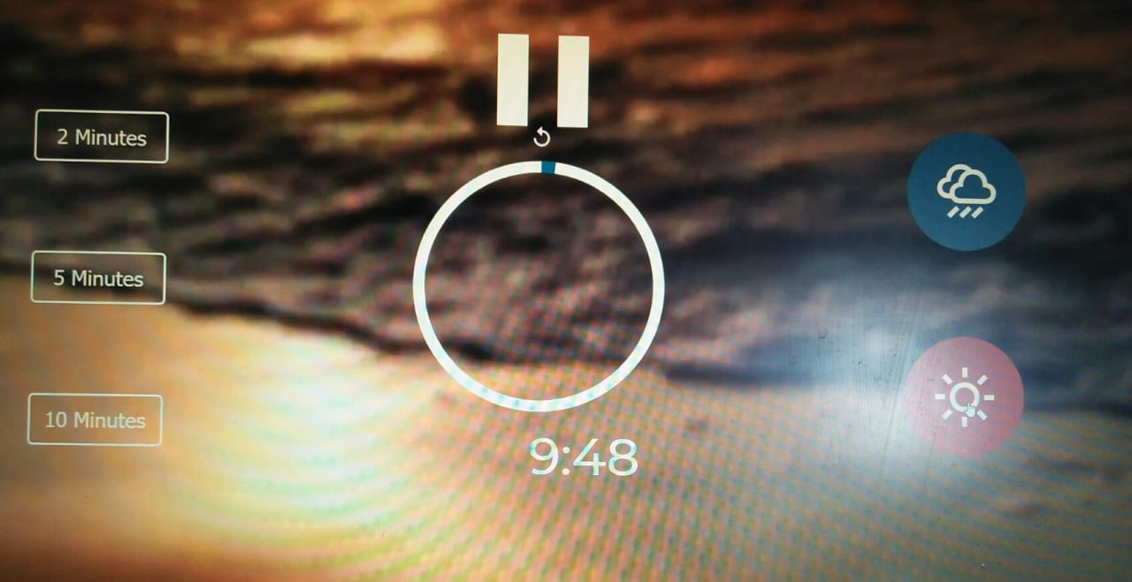

## **Twitter Feeds Page :-**

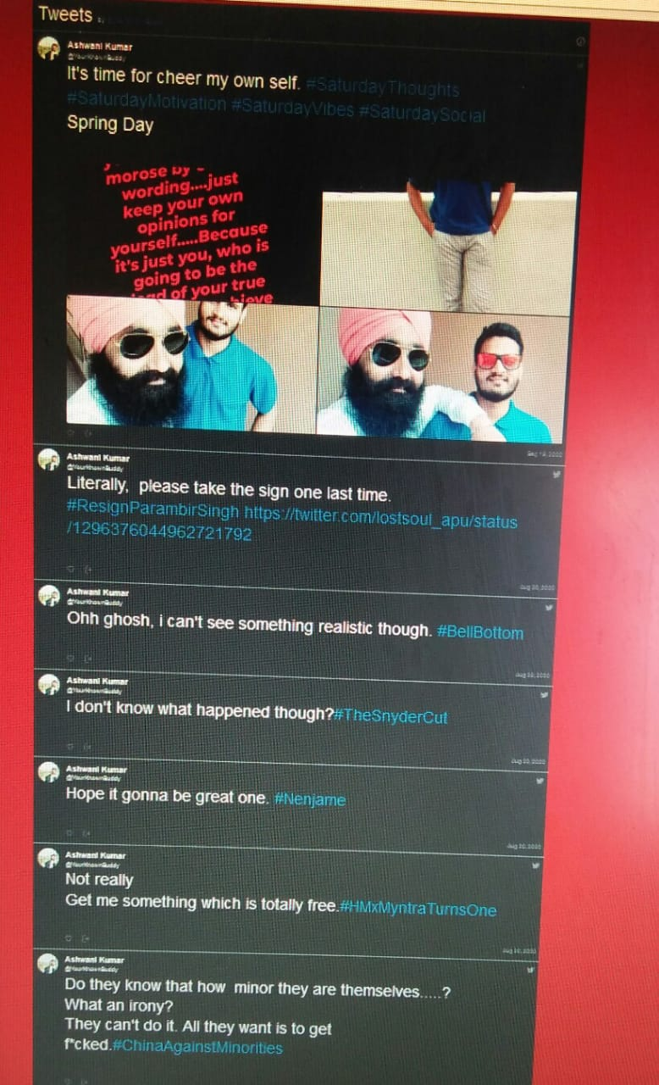

## **Online Transaction Page :-**

